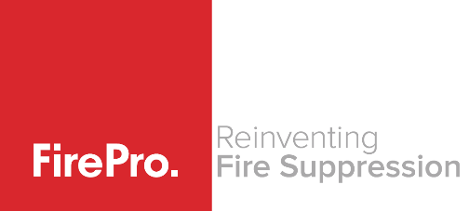 | CERTIFICATE OF CONFORMITY  Rev 2.0

Vessel :

ITEM DESCRIPTION: FIREPRO Fire Suppression System

We certify that the product(s) detailed hereon have been inspected and tested following requirements:
- Fire Suppression systems as approved by the Australian Maritime Safety Authority (AMSA) – NSCV.
- Fire Suppression systems required for Vessels operating under regulations issued by ……..

Signed: |  | Name
 |  | Position:
 |  | Date:

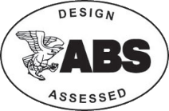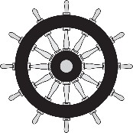
Commissioning of a FirePro Marine System
Rev 2.0
Vessel Description : |  | Reference :
INSPECTIONS
Task |  |  |  | Completed
- Location of FirePro Aerosol Generators - Ensure mounted in appropriate location.
- Mounting brackets - Are they suitable for application and securely mounted to hull or bulkhead.
- Cabling requirements - Is fire rated shielded cable used.
- Placement of Control panel:
  - Is the panel located in an appropriate location for viewing of indicator panel.
  - Can it be accessed for emergency operation.
  - Can it be accidentally activated.
- Power supply to Panel:
  - Is power connection a direct suitable uninterruptable power to panel (Green LED).
  - Separate Battery backup location and cabling.
- Signage - Have appropriate signs been installed. Are signs clearly visible to occupants.

COMMISSIONING TESTS
IMPORTANT - disconnect FirePro aerosol generator(s) and connect FirePro Test Module(s).
- Configuration of Control Panel – check the specific control panel requirements to the installation manual for the specific Control Panel. Ensure that all relevant settings have been configured.
- Activation of FirePro Units – Push the activation button & hold for approximately 4 seconds.
  - The alarm on the panel and the remote alarm should activate immediately.
  - Discharge fans etc connected to shut down relays will activate.
  - The FirePro test modules will activate after approximately 4 seconds, these lamps will be lit and will stay on to confirm activation. This will also create a fault on the panel – which simulates what would happen had the units activated. The test modules will need to be reset to clear the fault.
  - The control panel will indicate that the system has activated (Red flash on discharge button).
- Operation of Detectors – Apply a heat gun carefully to the detectors.
  - All alarms and warning lights should sound and flash. The panel will indicate (Red LED) that detection has occurred. For this test each detector should be tested separately.
- Fault Monitoring – Where multiple units are installed, each unit should be tested separately.
  - Disconnect cable from FirePro test module – Fault should indicate on panel
  - Remove detector head from base – Fault should indicate on panel.
Inspections all found to be compliant - Tests all completed.
Completed by :
Name: |  | Signature:
Company: |  | Date Completed:

